Mr. Randy Spencer
Troop 29 Committee Chair
102 Cardinal Circle
Hockessin, DE 19707

CONFIDENTIAL

EAGLE SCOUT

BOARD OF REVIEW

REFERENCE

YOUR NAME GOES HERE!!!!!!

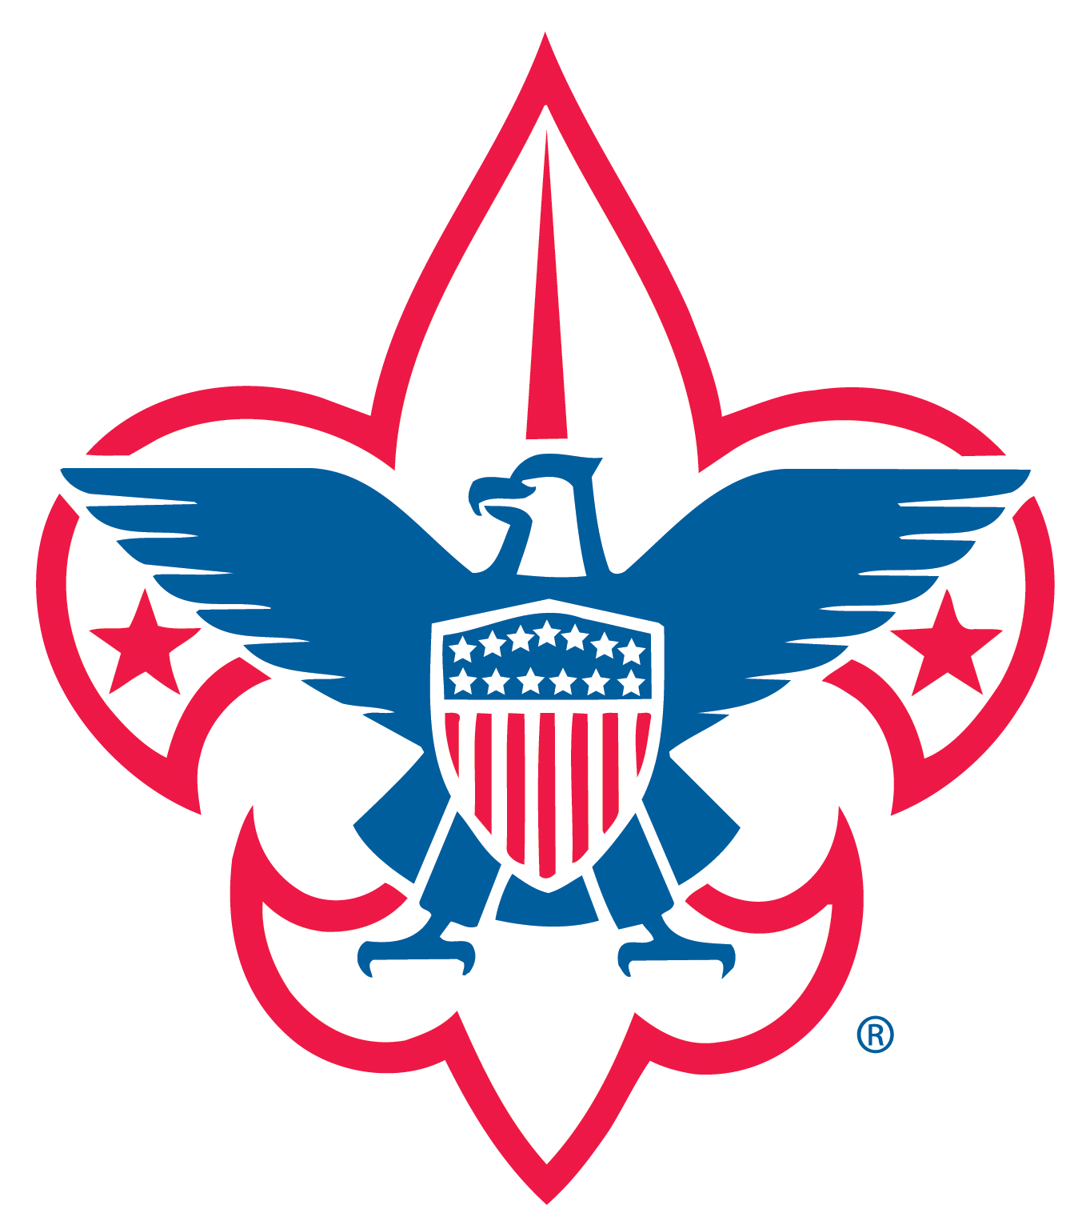
Troop 29
Boy Scouts of America
Red Clay Creek Presbyterian Church
Wilmington, DE

Dear Sir or Madam:

The young man presenting this to you is a Life Scout in Troop 29 in the DelMarVa Area Council of the Boy Scouts of America, and is a candidate for the rank of Eagle Scout, BSA’s highest rank.

As the final step in the process of determining the qualifications for the rank of Eagle Scout, an Eagle Scout Board of Review will be conducted. At that time, members of the Board of Review will discuss, with the Scout, his achievements as a Boy Scout, and in his daily life, and determine if he meets the requirements for the high rank of Eagle Scout. Those requirements include a series of advancements, the earning of at least 21 Merit Badges, and evidence of leadership skills. A candidate for Eagle Scout must serve in one or more leadership positions in the Troop, and must plan, develop, and lead others in a service project helpful to a religious institution, school, camp, or other community organization not affiliated with the Boy Scouts of America.

An Eagle Scout candidate must also demonstrate that he lives by the principles of the Scout Oath, and Law in his daily life. In this regard, the candidate has indicated that you know him personally, and that you would be willing to provide a letter of recommendation on his behalf. I have enclosed with this letter a copy of the Scout Oath and Law for your reference in preparing the letter. Please note that the contents of the letter will NOT be shown to or discussed with the candidate, nor with anyone who is not a member of the Eagle Scout Board of Review. Of course, you are free to discuss the information with him, if you so desire, but you are under no obligation to do so.

If you are willing to do so, please send a letter, addressed to me in the enclosed envelope, as soon as possible. If for any reason you are unwilling to provide such a letter, please notify the Scout, so that he may arrange for an alternative reference. Since the Eagle Board of Review cannot be held until we receive the references, an early reply would be appreciated.

Thank you for your cooperation.

Yours in Scouting,

Randy Spencer
Troop 29 Committee Chair

Enclosure

The Scout Oath

On my Honor, I will do my best
To do my duty to God and my country
and to obey the Scout Law;
To help other people at all times;
To keep myself physically strong,
mentally awake, and morally straight.

The Scout Law

A Scout is TRUSTWORTHY. A Scout tells the truth. He keeps his promises. Honesty is a part of his code of conduct. People can always depend on him.
A Scout is LOYAL. A Scout is true to his family, friends, Scout leaders, school, nation, and world community.
A Scout is HELPFUL. A Scout is concerned about other people. He willingly volunteers to help others without expecting payment or reward.
A Scout is FRIENDLY. A Scout is a friend to all. He is a brother to other Scouts. He seeks to understand others. He respects those with ideas and customs that are different from his own.
A Scout is COURTEOUS. A Scout is polite to everyone regardless of age or position. He knows that good manners make it easier for people to get along together
A Scout is KIND. A Scout understands there is strength in being gentle. He treats others as he wants to be treated. He does not harm or kill anything without reason.
A Scout is OBEDIENT. A Scout follows the rules of his family school, and troop. He obeys the laws of his community and country. If he thinks these rules and laws are unfair, he tries to have them changed in an orderly manner rather than disobey them.
A Scout is CHEERFUL. A Scout looks for the bright side of life. He cheerfully does tasks that come his way. He tries to make others happy.
A Scout is THRIFTY. A Scout works to pay his way and to help others. He saves for the future. He protects and conserves natural resources. He carefully uses time and property.
A Scout is BRAVE. A Scout can face danger even if he is afraid. He has the courage to stand for what be thinks is right even if others laugh at him or threaten him.
A Scout is CLEAN. A Scout keeps his body and mind fit and clean. He goes around with those who believe in living by these same ideals. He helps keep his home and community clean.
A Scout is REVERENT. A Scout is reverent toward God. He is faithful in his religious duties. He respects the beliefs of others.

